**Walmart-retail-dashboard**

**📊 project overview**

this project presents an interactive, dynamic dashboard based on the walmart dataset to analyze sales, profits, and order quantities across different regions, markets, segments, and product categories. the goal is to support walmart's leadership in making data-driven decisions through comprehensive insights and visualizations.

**📌 objective**

the objective of this project is to present insights from the exploratory data analysis (eda) in a structured and interactive dashboard format. the dashboard enables slicing and dicing of data to uncover key business metrics, performance indicators, and market trends.

**🧾 features of the dashboard**

the dashboard includes the following analytical components:

* 🔹 **important kpis** such as total sales, total profit, total quantity, number of orders, profitability, and average sales.
* 🔹 **category-wise total sales** represented using pie charts.
* 🔹 **segment-wise total sales %** to compare performance across customer segments.
* 🔹 **top 5 and bottom 5 sub-categories** by sales.
* 🔹 **sub-category-wise sales analysis** using bar charts.
* 🔹 **top 10 countries** based on total sales (displayed on a world map).
* 🔹 **region-wise total sales** bar chart.
* 🔹 dynamic filters for:
  + segment
  + order date
  + region
  + market
  + ship mode

**📁 dataset fields**

the walmart dataset contains the following fields:

| **field** | **description** |
| --- | --- |
| row id | unique identifier for each row |
| order id | unique identifier for each sales order |
| order date | date the order was placed |
| ship date | date the order was shipped |
| ship mode | mode of shipment |
| customer id | unique identifier for each customer |
| customer name | name of the customer |
| segment | customer segment |
| city | city where the order was shipped |
| state | state where the order was shipped |
| country | country where the order was shipped |
| postal code | shipping postal code |
| market | market where the order was placed |
| region | region of the order |
| product id | unique identifier for each product |
| category | main category of the product |
| sub-category | sub-category of the product |
| product name | name of the product |
| sales | total revenue generated |
| quantity | quantity of product ordered |
| discount | discount applied to the order |
| profit | profit margin from the order |
| shipping cost | cost of shipping |
| order priority | priority level assigned to the order |

**KPI**

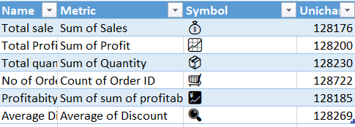

**🛠️ tools used**

* microsoft excel
* visual analytics techniques

**📷 dashboard preview**

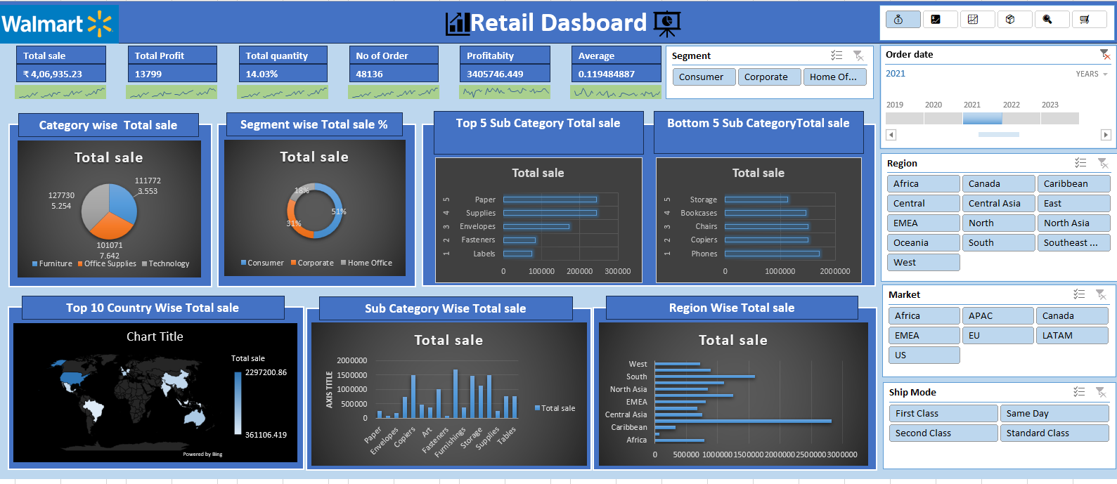

**🚀 how to use**

1. download or clone the repository.
2. open the excel dashboard.
3. interact with the slicers and filters to analyze sales metrics.
4. use the visuals to derive actionable insights for decision-making.